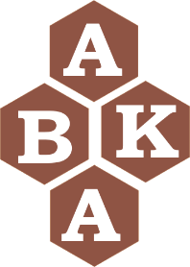2023 Bristol Honey Festival

Entry Form

Entries to be with the Show Secretary before 5 pm on 23rd August 2023
Fee: £1 per class up to maximum of £5 for all classes entered (pay on arrival)

CLASS | DESCRIPTION OF ENTRY | FEE
No. | TOTAL
Exhibitor’s Name ……………..........................……
Address …................................................................. ………………………………………………………
Postcode …........................…
Tel.no. …...................……………..….....
Email: …...............................................
Branch / Association: …......................………

DECLARATION (This must be completed for entries to be valid)

I have read and agree to abide by the Rules and Regulations of the Show and accept any decision of the Show Judge / Secretary / Committee as final.

Signature ………………………………………

Date ………….........................
Payment of entry fees: Pay cash on arrival

Apply by completing this form and e-mailing to: showsec@bristolbeekeepers.org.uk

Or
Send entry form by post to:

The Show Secretary
Fulligrove House, Woodwell Rd, Shirehampton
Bristol. BS11 9UG
Tel: 0117 9826455

